EXPERIMENT-1
Aim: Practice of LEX/YACC of compiler writing.
Theory
LEX is a lexical analyzer generator used in compiler writing. It takes a set of regular-expression patterns and their associated actions and generates C code for a lexical analyzer or scanner. The scanner reads the source input, matches strings according to the specified patterns, and converts them into tokens. Important Lex variables and functions include yytext, which contains the matched text; yyleng, which gives its length; yylex(), which invokes the lexical analyzer; and yywrap(), which is called when the input reaches the end.
A Lex program is divided into three sections: definitions, rules, and user subroutines, separated by %% lines. The rules section contains patterns followed by actions. Lex follows the longest-match rule; when two rules match the same amount of text, the rule appearing first is selected. LEX is commonly used together with YACC, where the lexer supplies tokens to the parser. The combination of lexical analysis and syntax analysis forms an important part of the front end of a compiler.
Practice Questions
1. Write a program to construct a small calculator that can add, subtract, multiply and divide in LEX.
%{
#include <stdio.h>
#include <stdlib.h>
int op = 0;
float a, b;
%}
dig [0-9]+(\.[0-9]+)?
add "+"
sub "-"
mul "*"
div "/"
ln \n
%%
{dig} {
if(op == 0)
a = atof(yytext);
else {
b = atof(yytext);
switch(op) {
case 1: a = a + b; break;
case 2: a = a - b; break;
case 3: a = a * b; break;
case 4: a = a / b; break;
}
op = 0;
}
}
{add} { op = 1; }
{sub} { op = 2; }
{mul} { op = 3; }
{div} { op = 4; }
{ln} {
printf("The Answer = %f\n", a);
}
%%
int main()
{
yylex();
return 0;
}
int yywrap()
{
return 1;
}
OUTPUT-
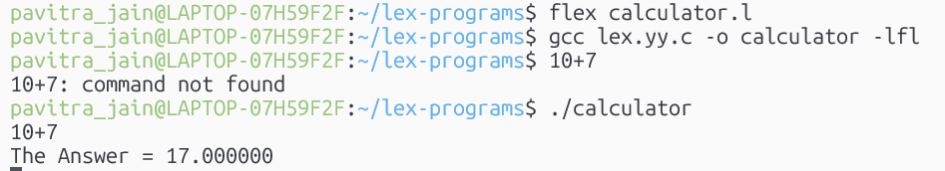

2. Write a program to match a string in LEX.
%{
#include <stdio.h>
#include <string.h>
%}
%%
[a-zA-Z]+ {
if(strcmp(yytext, "hello") == 0)
printf("String matched\n");
else
printf("String not matched\n");
}
\n ;
%%
int main()
{
yylex();
return 0;
}
int yywrap()
{
return 1;
}

OUTPUT-
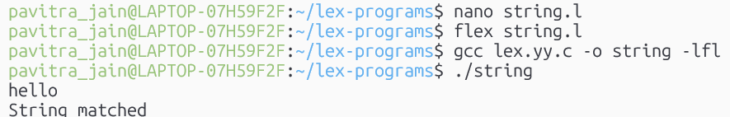

3. Write a LEX program to count the number of vowels and consonants in a given string.
%{
#include <stdio.h>
int vowels = 0;
int consonants = 0;
%}
%%
[aeiouAEIOU] {
vowels++;
}
[a-zA-Z] {
consonants++;
}
\n {
printf("Number of vowels = %d\n", vowels);
printf("Number of consonants = %d\n", consonants);
}
. ;
%%
int main()
{
printf("Enter a string: ");
yylex();
return 0;
}
int yywrap()
{
return 1;
}
OUTPUT-
